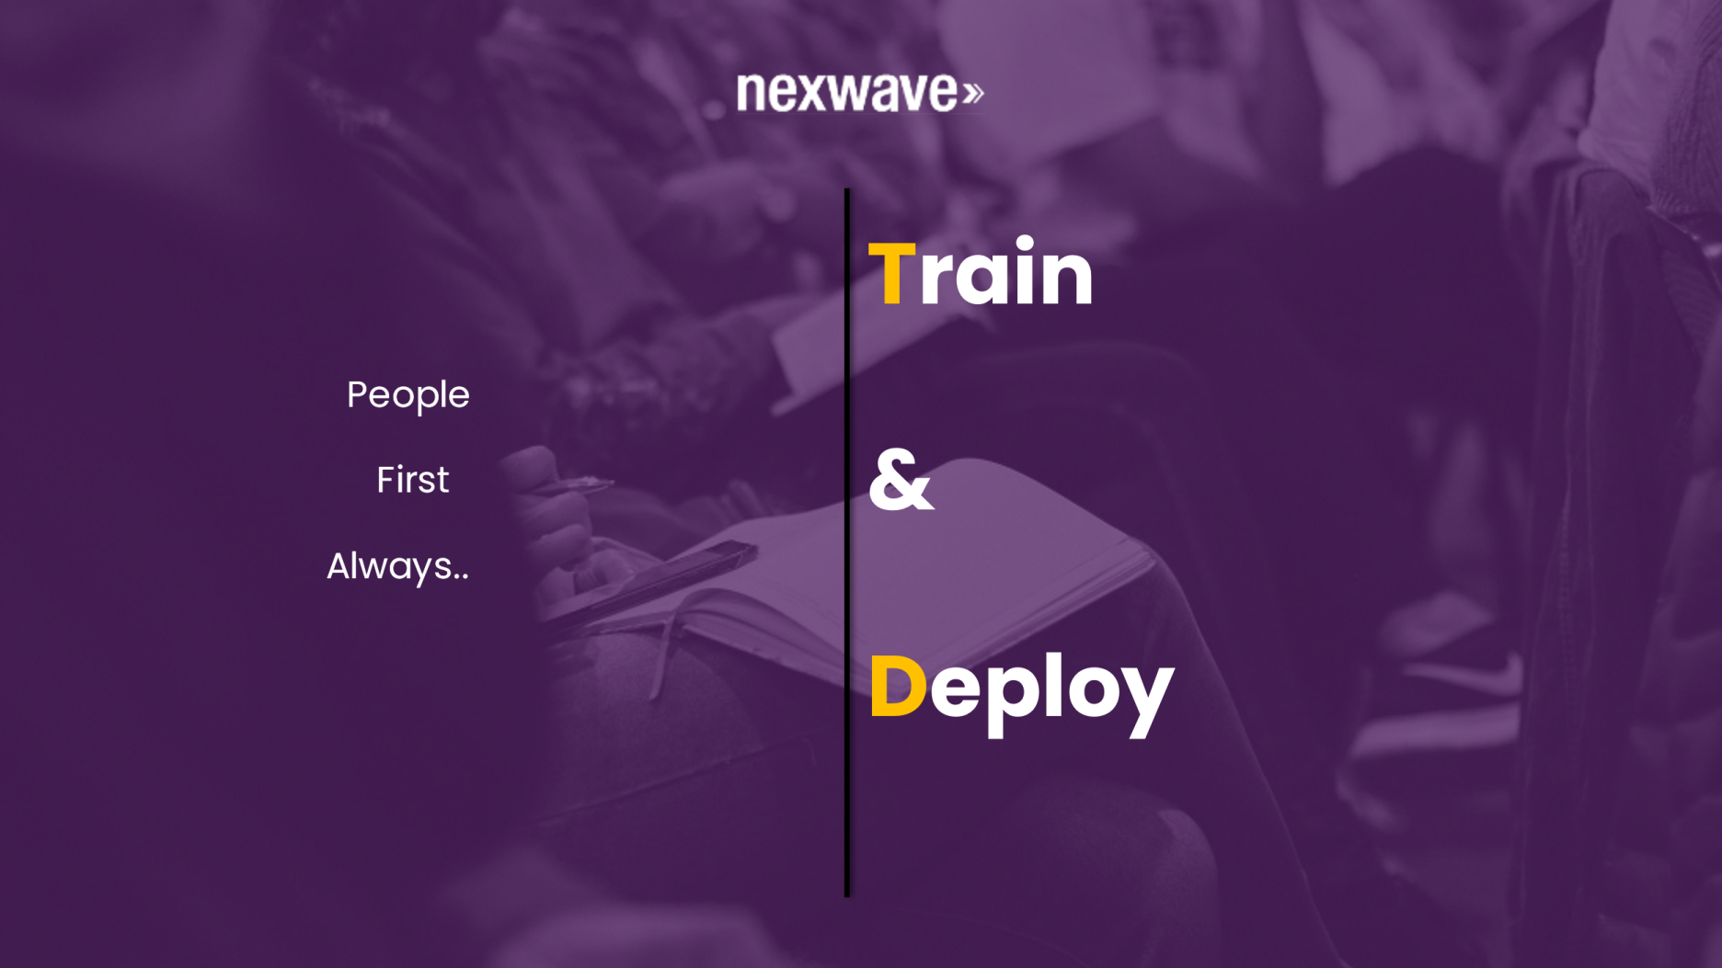

**Java Full Stack Training Curriculum**

By

**Nexwave Talent Management Solutions Pvt. Limited**

**20th July, 2022**

|  |  |  |  |
| --- | --- | --- | --- |
| **Skill:** | **Java Full stack** |  |  |
| **Topics** | **17** |  |  |
| **Days** | **62** |  |  |
| **Evaluation & Examinations** | **5+3** |  |  |
|  |  |  |  |
| **Topic** | **Sub-Topic** | **Duration in Days (62)** | **Evaluation/ Examination** |
| **Introduction to Java** | Introduction Java, keywords, loops Classes and Objects, Methods and Constructors, Static methods and Static variables | 4 |  |
| **Java Programming** | Class Relationships, Inheritance Polymorphism [overloading and overriding] | 4 |  |
| **Java Programming** | Abstract classes, Interfaces, Packages, final keyword, Arrays Strings | 4 | **Module Test || 5 %** |
| **Collections API & Exception Handling** | Collections ( List, Set, Map ) ----------------------------- Exception Handling | 3 |  |
| **MultiThreading & Java 8** | Creating Threads, Sleep, Join, Thread States, Synchronized . Java 8 Programming -Functional Interface and Default and static methods in interfaces, Lambdas, Method References Stream API and Collections. | 5 |  |
| **Junit5 JDBC and MySQL/oracle** | JUnit5: Assertions, JUnit Annotations: @Test @Before, @After,@AfterClass,@BeforeClass, @Rule and testing methods for exceptional conditions Need of RDBMS in an Applications, Using JDBC to connect to MySQL and showing CRUD operations and transaction Management.  Oracle | 4 | **Module Test || 5 %** |
| **Introduction to JPA/ORM (Hibernate JPA Provider)** | ORM introduction, Entity Life Cycle, CRUD operations, Strategies to Autogenerate Primary key | 3 | **Module Test || 5 %** |
| **Web Layer : Servlets & JSP** | HTML, CSS Refresher. Servlets: HTTP Servlet, JSP: scriptlets, JSTLs, JSTL | 3 |  |
| **UI** | React JS:  Architecture  Creating React Application  JSX  Components  Styling  Properties  Form buildng  redux  Routing  CLI Commands  Building & Deployment  Java Script  ES6/ES5 Fundmentals  TypeScripting: | 7 |  |
| **Spring Core** | Containers, IOC, Dependency injection and its type, Autowiring and its Types, xml configuration, java configurations and annotations, Reading value from Properties File | 4 |  |
| **Spring Core & Spring Test** | Spring Core Lifecycle , BeanFactoryPostProcessor, BeanPostProcessor, Mixed configuration, Environment specifc config Spring-Test, Spring Junit integration, Spring Context caching and Dirties Read annotation for reloading the context | 3 | **Mid Term || 25%** |
| **Spring MVC,Spring Form** | Spring-MVC: Controller, ModelAndView, parent context and child context. FormUI Components (static and dynamic), Validations (standard and custom) using annotations | 3 |  |
| **Spring REST** | Spring REST basics, Annotations , ResponseEntity Rest Template | 2 | **Module Test || 5 %** |
| **Spring Security** | Basics of security authorization and authentication, principal Authentication using InmemoryAutheticationProvider, JDBCAuthenticationProvider | 2 |  |
| **Build automation using Maven** | Explanation on Build of Project, What is Build Automation, Maven as Build Automation Tool,Maven Build Phases, | 2 |  |
| **Introduction to Microservices and Spring Boot** | ▪ Types of Applications ▪ Introduction to Microservices Architecture ▪ Best Practice: Loosely Coupled and Highly Cohesive Code ▪ Microservices vs Monolithic Architecture ▪ Microservices and SOAP based services comparisons ▪ 12 Factor App and SOLID Principle for Microservices Based Applications ▪ Java Technology Stack for development of Microservices Component ▪ Spring Data JPA and Spring REST, A brief Introduction to REST, HTTP Verbs (GET, PUT,POST,DELETE), HTTP Verb to CRUD mapping ▪Creating Microservice component using Spring REST and Spring JPA DATA (without boot) {Highlighting challenges and need of Spring Boot} | 3 |  |
| **Creating MicroServices using Spring Boot** | ▪ Creating First Spring Boot Project using: Initializer, Eclipse, STS ▪ Creating a Microservice Component using Spring Boot (Spring REST and Map based Data structure to store data) ▪ Discussion on: Automating Configuration, Creating Independent Deployment unit, Dependency Management, Fat Jar and Thin Jar ▪ Spring Boot REST validations using hibernate bean validation API(custom and standard), Externalizing the Validation Messages into properties file and Reading message from Properties file ▪ Content Negotiation ▪ Spring Boot Application using Spring-REST and Spring-JPA | 3 | **Module Test || 5 %** |
| **Creating MicroServices using Spring Boot** | ▪ Spring JPA Data how to write queries using @Query annotation and how externalize query and Spring JPA query method approach ▪ Spring JPA and Cache Management ▪ Introduction to Profiles, Customizer with profiles, Profile Specific Properties File, Properties File Inheritance ▪ Controller Testing using MockMVC for all the CRUD (integrationtesting with Database) ▪ Controller Testing using Mockito and MockMVC for all the CRUD (unit testing by mocking Database) ▪ REST Template to consume Spring REST Service(standard RestTemplate methods and exchange method) ▪ Spring Boot using YAML configuration ▪ Creating a Spring boot component using Spring boot 2.x (non reactive) ▪ Introduction to WADL, Documenting a microservice component using Swagger 2.x | 3 | **Final || 30% + 1 Weel for Term Paper (Presentation + Practical) || 20 %** |

**End.**